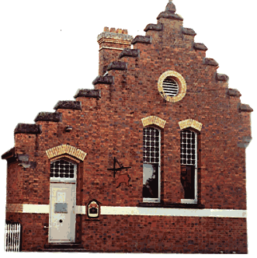

**BE A FRIEND TO THE BERRY MUSEUM**

Become a Member of the BERRY AND DISTRICT HISTORICAL SOCIETY

IT NEEDS YOUR SUPPORT

The BERRY & DISTRICT HISTORICAL SOCIETY Inc. is a voluntary, not for profit organisation which promotes knowledge of the unique history of Berry, its cultural heritage together with its natural beauty. The Museum needs people who have chosen to live here to promote and protect it. By becoming a friend, you can increase your knowledge about the Museum as well as recommending it to visitors and locals. This enables the Museum to stay open to visitors, providing access to research resources. Support of both the community and Shoalhaven Council is vital. We depend on members, visitors, private donations and grants for finance. As a friend you will have access to all the information at the Museum. You will be included in all social activities as well as receiving regular news of what is happening in the Museum and interesting historical items.

APPLICATION FOR MEMBERSHIP

Name:

Address:

Phone: Home

Work

Mobile

Email:

Annual Fees 1 July 2021 – 30 June 2022

Single Membership $25

Family Membership $30

Payment can be made by cheque, cash or bank transfer.

If paying by bank transfer, our bank details are:

BSB: 082-435

Account Number: 175071089

Account Name: Berry & District Historical Society

The Berry & District Historical Society Inc  
135 Queen Street, Berry.  
P.O. Box 153, Berry. NSW 2535

Phone: 02 4464 3097  
E-mail: berrymuseum@bigpond.com